**Sales, Ace Lawrence V.**

**2ECE – A**

**Experiment # 7**

**Problem 1**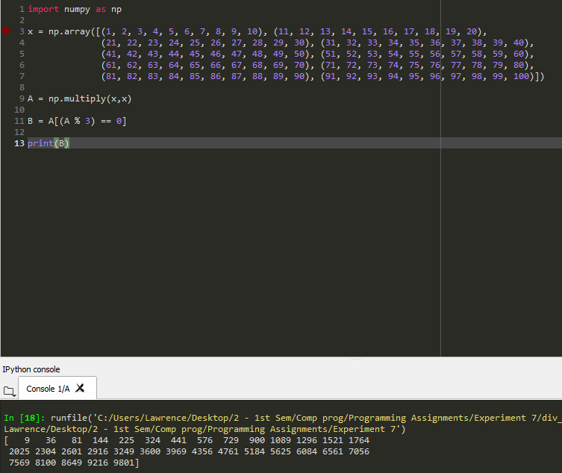

**Problem 2**

